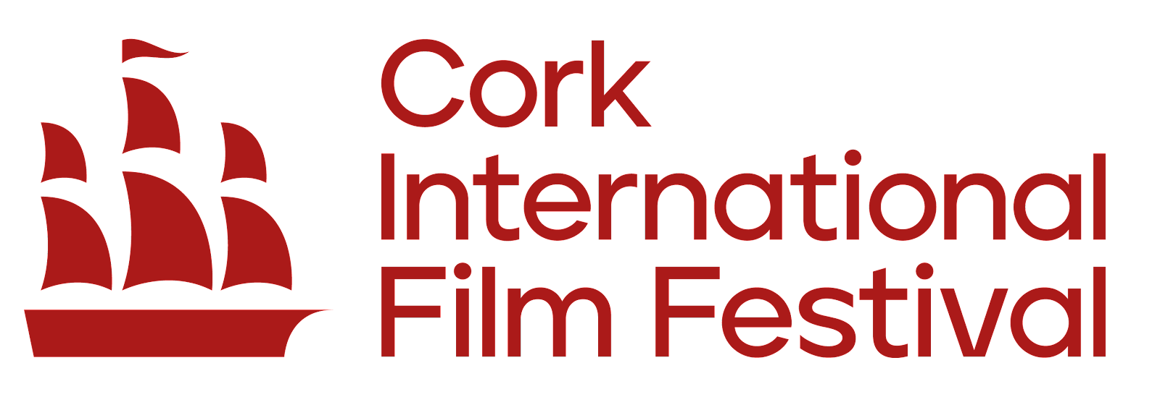
Cork International Film Festival Equality, Diversity and Inclusion Policy Statement
This policy statement sets out how Cork International Film Festival (CIFF) will promote Equality, Diversity and Inclusion (EDI) as an employer, arts organisation and provider of cultural experiences and services.
It outlines our commitment to embedding EDI across all areas of the organisation's work, including our employment practices, governance, programming, audience engagement, partnerships, volunteering and the communities within which we operate.
Cork International Film Festival is committed to promoting Equality, Diversity and Inclusion in all aspects of its activity, employment and operations. The Board of CIFF recognises equity, diversity, inclusion and accessibility as key organisational responsibilities and priorities and is committed to ensuring that these principles inform our decision-making and our relationships with audiences, artists, employees, volunteers, partners and stakeholders.
As a local festival with a global focus, CIFF has celebrated and promoted diverse voices, cultures, perspectives and lived experiences for over 70 years. Our programme reflects the breadth and diversity of society and the world’s stories, and continues to evolve in response to the communities we serve and the changing world around us.
We believe film is a powerful platform for sharing stories, raising awareness, encouraging discussion and debate, challenging perceptions and creating positive social impact. We are committed to using our platform to showcase a diverse range of lived experiences, voices and perspectives, and to creating opportunities for people from different backgrounds to participate in and contribute to the Festival.
We are committed to fostering an environment, both internally and externally, that promotes equality, respects difference and enables meaningful participation. We aim to ensure that everyone we work with, support and welcome to the Festival has equitable opportunities to participate and engage, regardless of age, civil status, disability, family status, gender, gender identity, race or ethnicity, religious belief, sexual orientation, membership of the Traveller community or socio-economic background.
Accessibility is an integral part of our EDI commitment. We recognise that barriers to participation can be physical, social, financial, cultural, digital or attitudinal, and we are committed to identifying and reducing these barriers across our employment, programming, venues, communications, audience engagement and wider activities.
CIFF recognises that EDI is an ongoing journey and that there is always more work to do. We are committed to learning, listening and improving our practice, and to using our position as a leading cultural organisation to contribute positively to a more equitable, diverse, inclusive and accessible society.
The Board has overall responsibility for this commitment, with implementation embedded across the organisation. Progress will be monitored through our EDI objectives, action plans and organisational reporting, with our approach reviewed regularly to ensure that it remains relevant, effective and responsive to the communities we serve.
Next Review Date: June 2027

